System Capacity & Care Loa Analytics for
Unaccompanied Children
1. Background and Context
Unaccompanied Children (UC) are minors who enter a country without a parent or legal guardian. These children require immediate support such as:
- Safe shelter
- Food and healthcare
- Emotional and psychological support
- Legal assistance
Government agencies and NGOs operate multiple shelters to accommodate these children. However, due to sudden surges in migration, shelters often face:
- Overcapacity issues
- Limited staff availability
- Uneven distribution of children across shelters
This creates a need for data analytics systems to monitor and optimize operations.
This project focuses on analysing system capacity (shelter space) and care load (staff workload) using data-driven techniques.
2. Problem Statement
Managing unaccompanied children is complex due to unpredictable arrivals and limited resources.
Key Problems:
- Shelters exceed their maximum capacity
- Staff-to-child ratio becomes unbalanced
- Delays in relocating children
- Lack of forecasting for future demand
Core Problem:
There is no efficient system to analyse current capacity and predict future demand, leading to overcrowding and reduced quality of care.
3. Primary Objectives
The main goals of this project are:
- Capacity Analysis
  - Measure how full each shelter is
  - Identify overcrowded shelters
- Care Load Monitoring
  - Calculate children per staff ratio
  - Detect staff overload situations
- Trend Analysis
  - Understand monthly and seasonal patterns
- Demand Forecasting
  - Predict future arrivals
  - Prepare shelters in advance
4. Secondary Objectives
- Improve decision-making using data insights
- Optimize resource allocation across shelters
- Reduce staff burnout
- Increase efficiency in relocation planning
- Provide visual dashboards for management

5. Dataset Description
The dataset is designed to simulate real-world shelter data.
Columns Explanation:
Column | Description
Child ID | Unique identifier for each child
Name | Child’s name (optional/dummy data)
Age | Age (0–17 years)
Gender | Male / Female
Arrival Date | Date child entered system
Shelter ID | Shelter assigned
Shelter Name | Name of shelter
Shelter Capacity | Maximum capacity
Current Occupancy | Current children count
Staff Count | Number of staff members
Care Load | Children per staff
Stay Duration | Days stayed
Exit Date | Date of leaving
Graph Analysis:
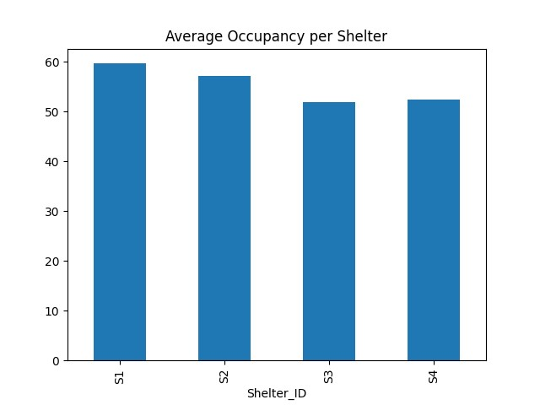
1. Shelter Occupancy (Bar Chart)
Explanation:
This bar chart represents the average number of children accommodated in each shelter. It helps in identifying which shelters are operating near or above their capacity.
Insight:
- Shelters with higher bars indicate overcrowding.
- These shelters require immediate attention and redistribution of children.
- Balanced occupancy improves overall system efficiency.
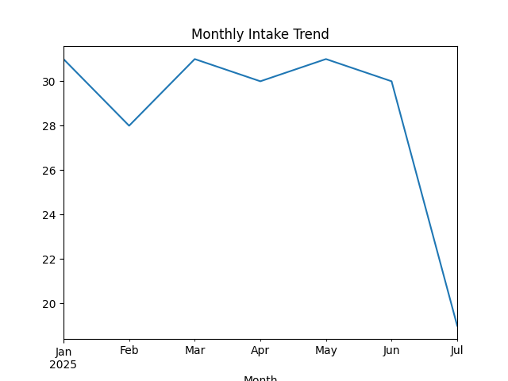
2.Monthly Intake Trend (Line Chart)
Explanation:
This line chart shows the number of children entering the system over time (monthly basis).
Insight:
- An increasing trend indicates rising migration or intake.
- Helps in planning future shelter capacity.
- Seasonal spikes can be identified for better preparedness.

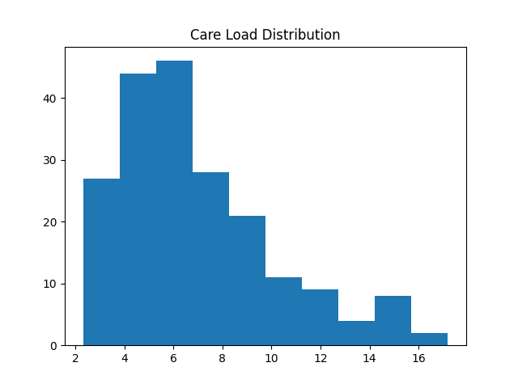
3. Care Load Distribution (Histogram)
Explanation:
This histogram shows how the workload (children per staff) is distributed across shelters.
Insight:
- High values indicate staff overload.
- Uneven distribution suggests inefficient staff allocation.
- Helps in optimizing workforce planning.

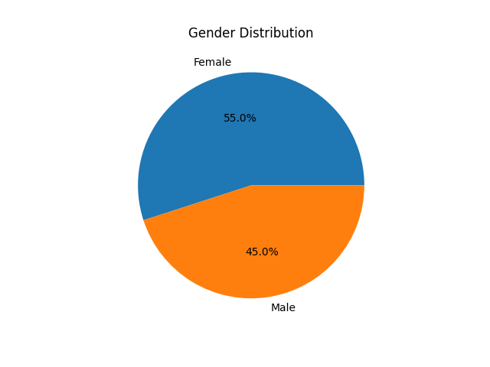
4. Gender Distribution (Pie Chart)
Explanation :
This pie chart displays the proportion of male and female children in the system.
Insight:
- Helps ensure gender-based resource allocation.
- Useful for planning separate facilities if required.
- Maintains balanced care services.

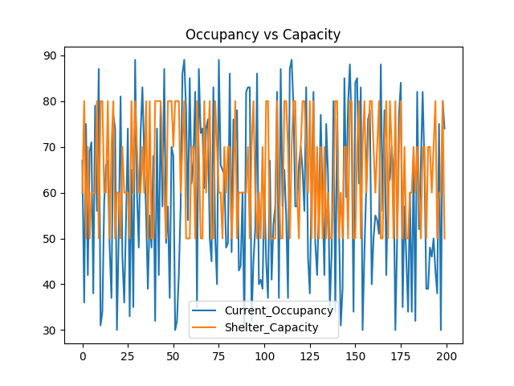

5.Occupancy vs Capacity (Comparison Chart)
Explanation:
This chart compares current occupancy with maximum shelter capacity.
Insight:
- If occupancy exceeds capacity → overcrowding
- Helps identify risk zones
- Supports decision-making for expansion or relocation
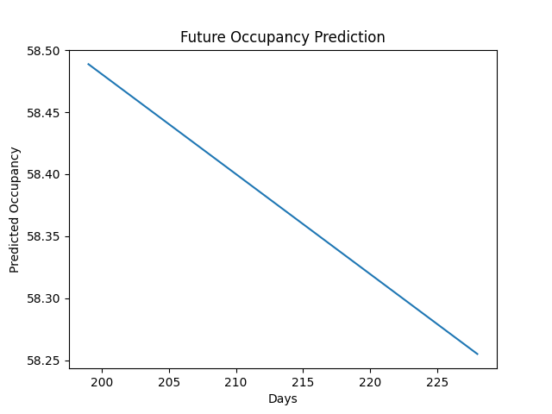

6. Future Prediction Graph (Forecast):
Explanation:
This graph shows predicted future occupancy based on historical data using a regression model.
Insight:
- Helps in planning future shelter requirements
- Predicts possible overcrowding
- Supports proactive decision-making
6.Forecasting Methodology:
Step 1: Data Collection
- Collect data from shelter records
- Include historical data (6 months–2 years)
Step 2: Data Cleaning
- Remove duplicate records
- Handle missing values
- Convert dates into proper format
Example:
- Fill missing staff count with average value
Step 3: Exploratory Data Analysis (EDA)
- Analyse:
- Monthly intake trends
- Shelter occupancy levels
- Staff workload distribution
Step 4: Feature Engineering
Create new variables:
- Occupancy Rate
= Current Occupancy / Shelter Capacity
- Care Load Ratio
= Children / Staff
- Monthly Intake
= Count of arrivals per month
Step 5: Model Selection
Use forecasting models:
- Linear Regression → Basic trend prediction
- ARIMA Model → Time series forecasting
- Moving Average → Smooth trends
Step 6: Model Training
- Split data:
  - 80% Training
  - 20% Testing
- Train model using historical data
Step 7: Prediction & Evaluation
Predict:
- Future number of children
- Future shelter occupancy
Evaluate model using:
- MAE (Mean Absolute Error)
- RMSE (Root Mean Square Error)
7. Key Performance Indicators (KPIs)
1. Occupancy Rate (%)
- Shows how full a shelter is
- Formula:
= (Current Occupancy / Capacity) × 100
2. Care Load per Staff
- Indicates staff workload
- High value = overload
3. Average Stay Duration
- Helps understand processing time
4. Intake Growth Rate
- Measures increase in arrivals
5. Overcapacity Rate
- Number of times shelter exceeds capacity
6. Staff Efficiency Ratio
- Balanced care vs staff availability
8. Stream lit Web Application Requirements
Purpose
To create an interactive dashboard for monitoring system performance.
Modules
1. Dashboard
- Total children
- Total shelters
- Average occupancy
2. Visualization Page
- Bar chart → Shelter occupancy
- Line chart → Monthly arrivals
- Pie chart → Gender distribution
3. Forecast Page
- Show predicted arrivals
- Future capacity alerts
4. KPIs Page
- Display all performance indicators
9. Tools and Technologies Used
- Python
- Pandas (Data Analysis)
- NumPy (Numerical Operations)
- Matplotlib (Visualization)
- Scikit-learn (Forecasting Model)
- Streamlit (Dashboard Development)
RESULTS & FINDINGS
Key Findings:
- Some shelters are operating close to or above their capacity.
- Care load varies significantly, indicating staff imbalance.
- Monthly intake shows a gradual increase, highlighting growing demand.
- Forecast results suggest future overcrowding if no action is taken.
10. Deliverables and Submission
- Dataset (Excel)
- Python Code
- Streamlit App
- Graphs
- Final Report
11. Conclusion
This project demonstrates how data analytics can significantly improve the management of unaccompanied children’s shelters.
By analysing capacity, workload, and trends:
- Overcrowding can be reduced
- Staff workload can be balanced
- Future demand can be predicted
The Stream lit dashboard provides an interactive platform for decision-makers to monitor system performance in real-time.
Future Scope:
- Integration with real-time data
- Use of advanced forecasting models (ARIMA, AI models)
- Deployment as a cloud-based system
This project highlights the use of data science techniques to solve real-world capacity and resource management problems.

